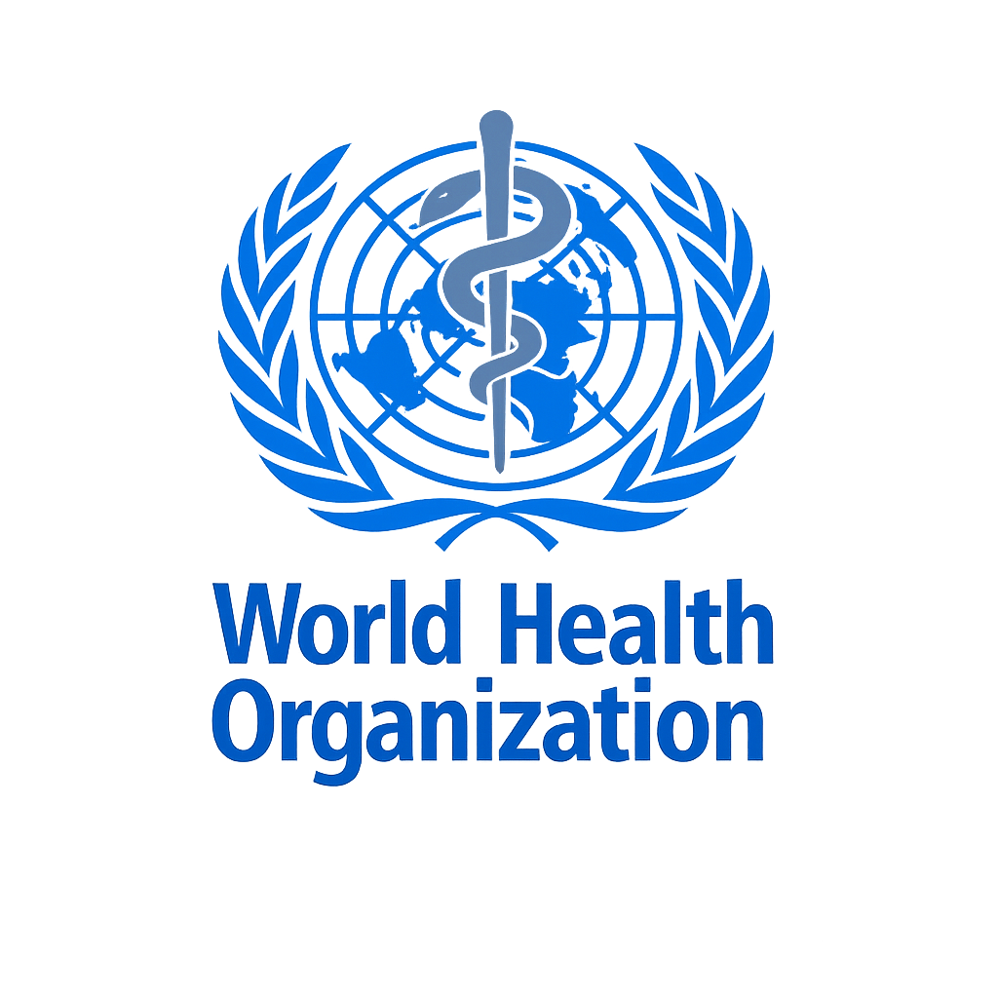Project Documentation:-

HEALTH VIRUSES
Made by:-
SHAYAN BUTT
Group Member:-
Waliuallah
Hadi
“Introduction”
This project is based on the study of some of the most common and serious infectious diseases that have affected people around the world. These diseases include COVID-19, Influenza (Flu), Dengue Virus, Smallpox, Rabies, HIV/AIDS, Hepatitis (A, B, and C), Zika Virus, Ebola Virus, and Yellow Fever. All of these diseases are caused by viruses and have created major health problems in different countries at different times.

“Importance of this Topic”
he importance of this topic is very high because infectious diseases continue to be a major threat to human life. Some of these diseases have caused worldwide outbreaks, while others are still common in many developing regions. Lack of awareness, poor healthcare facilities, and late treatment often make these diseases more dangerous. By learning about these illnesses, people can better understand how they spread and how they can be prevented. International organizations like the World Health Organization (WHO) play an important role in controlling such diseases and spreading health awareness.

“Main Aim”
he main aim of this project is to create awareness about common and dangerous viral diseases and to provide basic knowledge about their causes, effects, and prevention. This project also aims to highlight the importance of public health awareness, vaccination, and global cooperation in reducing the spread of infectious diseases and protecting human life.

“Timeline of Major Viral Diseases”

VIRAL DISEASES
|
-------------------------------------------------
| | | |
Respiratory Vector-Borne Blood-Borne Other Viral
Viruses Viruses Viruses Diseases
| | | |
| | | |
COVID-19 Dengue Virus HIV / AIDS Smallpox
(2019) (1943) (1981) (Ancient)

Influenza Zika Virus Hepatitis A Rabies
(1918) (1947) (1973) (1885)

Ebola Virus Hepatitis B Yellow Fever
(1976) (1965) (1901)

Hepatitis C
(1989)

“COVID-19 (Coronavirus Disease 2019)”
- Introduction:-
COVID-19 is an infectious disease caused by the novel coronavirus known as SARS-CoV-2. The disease was first identified in late 2019 and quickly spread across the world, leading to a global pandemic. COVID-19 mainly affects the respiratory system and can range from mild symptoms to severe illness
- Origin and Discovery:-
COVID-19 was first reported in December 2019. Due to its rapid spread across countries and continents, it became a major global health emergency. The World Health Organization (WHO) officially declared COVID-19 a pandemic in March 2020.
- Cause of COVID-19:-
COVID-19 is caused by a virus called Severe Acute Respiratory Syndrome Coronavirus 2 (SARS-CoV-2).
This virus belongs to the coronavirus family, which can infect both animals and humans.
- Mode of Transmission:-
COVID-19 spreads mainly through:
- Respiratory droplets released when an infected person coughs, sneezes, or talks
- Close physical contact with an infected person
- Touching contaminated surfaces and then touching the face (mouth, nose, or eyes)

- Common Symptoms
Symptoms of COVID-19 may appear within a few days after infection and can include:
- Fever
- Dry cough
- Sore throat
- Fatigue
- Loss of taste or smell
- Shortness of breath
In severe cases, it can cause pneumonia and breathing difficulties.
- Impact on Global Health
COVID-19 had a serious impact on global health systems, economies, and daily life. Hospitals faced pressure, travel was restricted, and many countries experienced lockdowns. The pandemic highlighted the importance of healthcare preparedness and global cooperation.
- Prevention Methods
Preventive measures for COVID-19 include:
- Wearing face masks
- Washing hands regularly with soap or sanitizer
- Maintaining social distance
- Avoiding crowded places
- Getting vaccinated

- Vaccination
Vaccines were developed to reduce the severity and spread of COVID-19. Vaccination played an important role in controlling the pandemic and reducing hospitalizations and deaths.
- Role of World Health Organization (WHO)
The World Health Organization (WHO) played a key role by:
- Providing health guidelines
- Supporting vaccination programs
- Monitoring the global spread of the disease
- Assisting countries during health emergencies

- Conclusion
COVID-19 is one of the most significant health crises in modern history. It showed how quickly infectious diseases can spread and affect the entire world. Awareness, prevention, and global cooperation are essential to manage such health threats in the future.

“Dengue Virus”
- Introduction:-
Dengue is a viral disease that is mainly found in tropical and subtropical regions. It is caused by the Dengue virus and is commonly spread through mosquito bites. Dengue has become a serious public health problem in many countries, especially during the rainy season.
- Origin and Discovery:-
Dengue fever was first identified in the early 20th century, with major outbreaks reported in different parts of the world. Over time, the disease spread rapidly due to urbanization, poor sanitation, and increased mosquito breeding.
- Cause of Dengue:-
Dengue is caused by the Dengue virus, which belongs to the Flavivirus family. There are four different types of Dengue virus, and infection with one type does not provide complete protection against the others.
- Mode of Transmission:-
Dengue spreads through the bite of an infected Aedes mosquito, mainly Aedes aegypti.
This mosquito usually bites during the daytime.
- Common Symptoms:-
Common symptoms of Dengue include:
- High fever
- Severe headache
- Pain behind the eyes
- Muscle and joint pain
- Nausea and vomiting
- Skin rash
In severe cases, Dengue can lead to Dengue Hemorrhagic Fever, which can be life-threatening.
- Impact on Public Health
Dengue places a heavy burden on healthcare systems, especially in developing countries. Frequent outbreaks cause hospital overcrowding and increase healthcare costs. Dengue also affects daily life and productivity.
- Prevention Methods
Preventive measures include:
- Eliminating standing water to prevent mosquito breeding
- Using mosquito nets and repellents
- Wearing protective clothing
- Keeping surroundings clean

- Treatment
There is no specific antiviral treatment for Dengue. Treatment mainly focuses on relieving symptoms through rest, hydration, and medical care. Early diagnosis and proper treatment can reduce complications.
- Role of World Health Organization (WHO)
The World Health Organization (WHO) supports Dengue control by:
- Providing prevention guidelines
- Supporting surveillance programs
- Promoting public awareness
- Assisting countries during Dengue outbreaks
- Conclusion
Dengue is a serious viral disease that continues to threaten public health in many parts of the world. Proper awareness, mosquito control, and timely medical care are essential to reduce the spread and impact of Dengue.

“HIV / AIDS”
- Introduction
HIV (Human Immunodeficiency Virus) is a viral infection that attacks the human immune system. If not treated properly, HIV can lead to AIDS (Acquired Immunodeficiency Syndrome), which is the most advanced stage of the infection. HIV/AIDS remains a major global health issue, affecting millions of people worldwide.
- Origin and Discovery
HIV was first identified in the early 1980s. In 1981, cases of unusual infections were reported, which later led to the discovery of HIV as the cause. Since then, HIV has spread globally and continues to be a serious public health concern.
- Cause of HIV / AIDS
HIV is caused by the Human Immunodeficiency Virus. The virus weakens the immune system by attacking CD4 cells, which are essential for fighting infections. Over time, this makes the body more vulnerable to diseases.
- Mode of Transmission
HIV is transmitted through:
- Unprotected sexual contact with an infected person
- Sharing contaminated needles or syringes
- Blood transfusion with infected blood
- From mother to child during pregnancy, childbirth, or breastfeeding
HIV does not spread through casual contact such as hugging or sharing food.
- Common Symptoms
In the early stage, symptoms may include:
- Fever
- Fatigue
- Swollen lymph nodes
- Sore throat
As the disease progresses, the immune system becomes weaker, leading to serious infections and illnesses.
- Impact on Global Health
HIV/AIDS has caused millions of deaths and has had a significant social and economic impact worldwide. It affects individuals, families, and communities, especially in developing countries. Stigma and lack of awareness often make the situation worse.
- Prevention Methods
Prevention of HIV includes:
- Practicing safe sex
- Using sterile needles and syringes
- Screening blood before transfusion
- Regular testing and awareness programs

- Treatment
Although there is no cure for HIV, antiretroviral therapy (ART) helps control the virus. With proper treatment, people living with HIV can lead long and healthy lives and reduce the risk of transmission.
- Role of World Health Organization (WHO)
The World Health Organization (WHO) works to:
- Promote HIV prevention and testing
- Support treatment and care programs
- Reduce stigma and discrimination
- Assist countries in controlling HIV/AIDS

- Conclusion
HIV/AIDS is a serious but manageable disease with proper awareness and medical care. Early diagnosis, prevention, and continuous treatment are essential to control its spread and improve the quality of life of affected individuals

Smallpox
- Introduction
Smallpox was a highly contagious and deadly viral disease that affected humans for centuries. It was caused by the Variola virus and mainly spread from person to person. Smallpox is one of the most dangerous diseases in human history, but it has been completely eradicated due to successful vaccination programs.

- Origin and History
Smallpox is an ancient disease that existed thousands of years ago. Historical records show evidence of smallpox in early civilizations. Due to its severe nature, it caused widespread outbreaks and high death rates across the world.
- Cause of Smallpox
Smallpox was caused by the Variola virus. There were two main forms of the virus: Variola major and Variola minor. Variola major was more severe and had a higher death rate.
- Mode of Transmission
Smallpox spread through:
- Direct contact with an infected person
- Respiratory droplets during coughing or sneezing
- Contact with contaminated clothing or bedding
- Common Symptoms
Symptoms of smallpox included:
- High fever
- Severe headache
- Body aches
- Skin rash that developed into pus-filled blisters
- Scarring after recovery
- Impact on Human Health
Smallpox caused millions of deaths throughout history and left many survivors with permanent scars or blindness. The disease had a devastating impact on societies and healthcare systems.
- Prevention and Eradication
Vaccination was the key method used to prevent smallpox. A global vaccination campaign led by the World Health Organization (WHO) successfully eliminated the disease. In 1980, WHO officially declared smallpox eradicated.
- Role of World Health Organization (WHO)
The World Health Organization (WHO) coordinated international efforts to vaccinate populations, monitor cases, and ultimately eradicate smallpox. This achievement is considered one of the greatest successes in public health history.
- Conclusion
Smallpox is the only human disease that has been completely eradicated through vaccination. Its elimination proves the importance of global cooperation, awareness, and effective public health strategies in controlling infectious diseases.

Influenza (Flu)
- Introduction
Influenza, commonly known as the flu, is a contagious viral infection that mainly affects the respiratory system. It is caused by the Influenza virus and spreads easily from person to person. Influenza occurs every year and can range from mild illness to severe health complications.

- Origin and History
Influenza has been known for many centuries, with several major outbreaks recorded in history. One of the most severe outbreaks was the 1918 Influenza pandemic, which affected millions of people worldwide. Since then, influenza continues to cause seasonal epidemics.

- Cause of Influenza
Influenza is caused by the Influenza virus, which is divided into different types, mainly Influenza A, B, and C. These viruses frequently change, which is why new flu strains appear every year.
- Mode of Transmission
Influenza spreads through:
- Respiratory droplets released during coughing or sneezing
- Close contact with an infected person
- Touching contaminated surfaces and then touching the face
- Common Symptoms
Common symptoms of influenza include:
- Fever and chills
- Cough
- Sore throat
- Runny or blocked nose
- Headache
- Muscle pain
- Fatigue
- Impact on Public Health
Influenza affects millions of people each year and places pressure on healthcare systems. Elderly people, children, and individuals with weak immune systems are at higher risk of serious complications.
- Prevention Methods
Preventive measures include:
- Annual flu vaccination
- Regular hand washing
- Covering mouth and nose while coughing or sneezing
- Avoiding close contact with sick individuals
- Treatment
Treatment for influenza mainly focuses on rest, fluids, and symptom relief. Antiviral medicines may be prescribed in severe cases, especially for high-risk patients.
- Role of World Health Organization (WHO)
The World Health Organization (WHO) monitors influenza strains worldwide and provides guidance on vaccination and prevention strategies to reduce the spread of the flu.
- Conclusion
Influenza is a common but potentially serious viral disease. Regular vaccination, early treatment, and awareness are essential to reduce its impact and protect public health.

Rabies
- Introduction
Rabies is a serious viral disease that affects the central nervous system of humans and animals. It is mainly transmitted through the bite of an infected animal. Rabies is almost always fatal once symptoms appear, but it is completely preventable with timely medical treatment.
- Origin and History
Rabies is an ancient disease and has been known for thousands of years. Historical records show that rabies existed in early civilizations. Despite medical progress, rabies remains a major public health concern in many developing countries.
- Cause of Rabies
Rabies is caused by the Rabies virus, which belongs to the Lyssavirus genus. The virus attacks the brain and spinal cord, leading to severe neurological symptoms.
- Mode of Transmission
Rabies spreads through:
- Bite or scratch from an infected animal
- Contact of infected saliva with broken skin or mucous membranes
Common animals that spread rabies include dogs, bats, cats, and wild animals.
- Common Symptoms
Early symptoms of rabies include:
- Fever
- Headache
- Weakness
As the disease progresses, symptoms may include:
- Fear of water (hydrophobia)
- Difficulty swallowing
- Confusion and agitation
- Paralysis

- Impact on Public Health
Rabies causes thousands of deaths every year, especially in Asia and Africa. The disease mainly affects people in rural areas where access to vaccination and medical care is limited.
- Prevention Methods
Rabies can be prevented by:
- Vaccinating domestic animals
- Avoiding contact with stray or wild animals
- Immediate washing of wounds after animal bites
- Taking post-exposure vaccination promptly
- Treatment
There is no cure for rabies once symptoms appear. However, immediate medical treatment after exposure, including vaccination and immunoglobulin, can prevent the disease.
- Role of World Health Organization (WHO)
The World Health Organization (WHO) works with countries to:
- Promote rabies vaccination programs
- Improve access to treatment
- Reduce rabies-related deaths globally
- Conclusion
Rabies is a deadly but preventable disease. Public awareness, animal vaccination, and early medical care are essential to eliminate rabies and save human lives.

Ebola Virus Disease (EVD)
- Introduction
Ebola Virus Disease (EVD) is a severe and often fatal viral illness that affects humans and animals. It is caused by the Ebola virus and is known for its high death rate. Ebola outbreaks mainly occur in parts of Africa and require immediate medical and public health response.
- Origin and Discovery
Ebola was first identified in 1976 during outbreaks in Central Africa. The disease was named after the Ebola River, near where one of the first outbreaks occurred. Since then, several outbreaks have been reported.
- Cause of Ebola
Ebola is caused by the Ebola virus, which belongs to the Filoviridae family. The virus attacks the immune system and causes severe damage to organs.
- Mode of Transmission
Ebola spreads through:
- Direct contact with blood or body fluids of an infected person
- Contact with contaminated objects such as needles
- Contact with infected animals
Ebola does not spread through air like flu.
- Common Symptoms
Symptoms of Ebola include:
- High fever
- Severe headache
- Muscle pain
- Vomiting and diarrhea
- Internal and external bleeding in severe cases
- Impact on Public Health
Ebola outbreaks cause fear, high death rates, and strain healthcare systems. They also affect social life and economies in affected regions.
- Prevention Methods
Preventive measures include:
- Avoiding contact with infected individuals
- Using protective equipment in healthcare settings
- Safe burial practices
- Public health education
- Treatment
There is no simple cure for Ebola, but supportive medical care improves survival. This includes fluids, medications, and close monitoring. Vaccines have also been developed to help prevent Ebola.
- Role of World Health Organization (WHO)
The World Health Organization (WHO) helps by:
- Coordinating outbreak response
- Providing medical guidelines
- Supporting vaccination efforts
- Assisting affected countries

- Conclusion
Ebola is a dangerous viral disease that requires quick action and global cooperation. Early detection, proper treatment, and strong public health measures are key to controlling Ebola outbreaks.

Hepatitis (A, B, and C)
- Introduction
Hepatitis is a viral infection that affects the liver and can cause both short-term and long-term health problems. There are several types of hepatitis, including Hepatitis A, B, and C. Each type differs in mode of transmission, severity, and treatment. Hepatitis remains a major public health issue globally, affecting millions of people.
- Origin and History
- Hepatitis A was first identified in the early 20th century and is usually associated with contaminated food and water.
- Hepatitis B was discovered in 1965 and is transmitted through blood and bodily fluids.
- Hepatitis C was identified in 1989 and is mainly transmitted through blood contact.
These infections have caused widespread illness and have significant social and economic impact.
- Cause of Hepatitis
- Hepatitis A Virus (HAV): Spread through contaminated food or water.
- Hepatitis B Virus (HBV): Spread through blood, sexual contact, or from mother to child during birth.
- Hepatitis C Virus (HCV): Spread mainly through blood contact, especially via unsterilized needles.
All types affect the liver, causing inflammation and sometimes long-term liver damage.
- Mode of Transmission
- Hepatitis A: Oral-fecal route (contaminated food/water)
- Hepatitis B: Blood, sexual contact, mother-to-child
- Hepatitis C: Blood-to-blood contact
- Common Symptoms
Symptoms may vary depending on the type, but common signs include:
- Fatigue
- Loss of appetite
- Nausea and vomiting
- Yellowing of the skin and eyes (jaundice)
- Abdominal pain
Chronic hepatitis (especially B and C) can lead to liver cirrhosis and liver cancer.
- Impact on Public Health
Hepatitis infections cause millions of deaths each year due to liver complications. Chronic infections lead to long-term health issues and burden healthcare systems. Awareness, vaccination, and safe medical practices are critical to prevent outbreaks.
- Prevention Methods
- Vaccination: Effective vaccines are available for Hepatitis A and B.
- Safe food and water practices: Important for preventing Hepatitis A.
- Avoid sharing needles: Critical for Hepatitis B and C.
- Safe sexual practices: Reduce the risk of Hepatitis B.
- Treatment
- Hepatitis A usually resolves on its own with supportive care.
- Hepatitis B can be managed with antiviral medicines.
- Hepatitis C can now be cured with antiviral treatments if detected early.
- Role of World Health Organization (WHO)
The World Health Organization (WHO) works to:
- Promote vaccination programs for Hepatitis A and B
- Raise awareness about transmission and prevention
- Support countries in screening and treatment programs

- Conclusion
Hepatitis is a serious liver disease with multiple viral types. Vaccination, hygiene, and early detection are key to controlling its spread and reducing long-term complications. Global awareness and healthcare support play a vital role in managing hepatitis worldwide.

Zika Virus
- Introduction
Zika Virus is a viral infection primarily transmitted by mosquitoes, especially the Aedes aegypti species. It gained global attention due to its rapid spread and link to birth defects when pregnant women are infected. While Zika is usually mild in adults, its potential effects on unborn children make it a serious public health concern.
- Origin and Discovery
Zika virus was first identified in 1947 in the Zika Forest of Uganda. For decades, it caused only occasional infections in humans. However, in the 21st century, large outbreaks occurred in South America, Central America, and parts of Asia, leading to global awareness about its health risks.
- Cause of Zika Virus
Zika is caused by the Zika virus, which belongs to the Flavivirus family, the same family as Dengue and Yellow Fever viruses. The virus primarily targets human cells and can cross the placental barrier, affecting fetal development.
- Mode of Transmission
Zika spreads mainly through:
- Bite of infected Aedes mosquitoes
- From mother to child during pregnancy
- Sexual transmission from an infected person
- Blood transfusion in rare cases
Zika does not spread through casual contact such as touching or hugging.
- Common Symptoms
Symptoms of Zika virus infection are usually mild and may include:
- Fever
- Rash
- Headache
- Joint and muscle pain
- Red eyes (conjunctivitis)
- Fatigue
Many infected individuals may not show any symptoms.
- Impact on Public Health
Zika virus gained global attention due to its link with microcephaly and other birth defects in babies born to infected mothers. It also poses challenges for public health systems in affected regions, especially in controlling mosquito populations.
- Prevention Methods
Preventive measures include:
- Using mosquito repellents
- Wearing long-sleeved clothing
- Sleeping under mosquito nets
- Eliminating standing water to reduce mosquito breeding
- Safe sexual practices to prevent transmission
- Treatment
There is no specific antiviral treatment for Zika virus. Supportive care, such as rest, hydration, and pain relievers, is recommended. Pregnant women are advised to take extra precautions to avoid infection.
- Role of World Health Organization (WHO)
The World Health Organization (WHO) assists countries by:
- Monitoring outbreaks
- Providing health guidelines for prevention
- Educating the public about risks and preventive measures
- Supporting research and response strategies

- Conclusion
Zika virus is a mild but potentially dangerous disease due to its effects on unborn children. Awareness, mosquito control, and preventive measures are essential to limit its spread and protect public health.

Yellow Fever
- Introduction
Yellow Fever is a viral disease transmitted by mosquitoes, primarily the Aedes and Haemagogus species. It is named “yellow” because of the jaundice (yellowing of the skin and eyes) that appears in severe cases. The disease can range from mild symptoms to serious, life-threatening illness, making it a major public health concern in affected regions.
- Origin and History
Yellow Fever has been known for centuries and caused significant outbreaks in Africa and the Americas. The virus was first isolated in 1927. Major epidemics in the 18th and 19th centuries caused high mortality rates and economic disruption.
- Cause of Yellow Fever
Yellow Fever is caused by the Yellow Fever virus, which belongs to the Flavivirus family, the same family as Dengue and Zika viruses. The virus primarily attacks the liver, leading to jaundice and other complications.
- Mode of Transmission
Yellow Fever spreads through:
- Bite of infected mosquitoes (Aedes and Haemagogus)
- Rarely, transmission can occur in laboratory settings
It does not spread directly from person to person.
- Common Symptoms
Symptoms of Yellow Fever can appear 3–6 days after infection and include:
- Fever and chills
- Headache
- Muscle and joint pain
- Nausea and vomiting
- Jaundice (yellowing of the skin and eyes) in severe cases
- Bleeding and organ failure in critical cases
- Impact on Public Health
Yellow Fever outbreaks can cause high mortality rates and overwhelm healthcare systems. It affects tropical regions in Africa and South America, especially where mosquito control is poor and vaccination coverage is low.
- Prevention Methods
Prevention of Yellow Fever includes:
- Vaccination (highly effective)
- Using mosquito repellents and nets
- Eliminating standing water to reduce mosquito breeding
- Wearing protective clothing
- Treatment
There is no specific antiviral treatment for Yellow Fever. Supportive care, including hydration, pain relief, and hospitalization in severe cases, is provided. Vaccination is the most effective preventive measure.
- Role of World Health Organization (WHO)
The World Health Organization (WHO) helps by:
- Promoting mass vaccination campaigns
- Monitoring outbreaks and providing guidelines
- Supporting countries in controlling mosquito populations
- Educating the public about prevention
- Conclusion
Yellow Fever is a dangerous but preventable viral disease. Vaccination, mosquito control, and public health awareness are essential to reduce its spread and protect vulnerable populations. Global cooperation and timely preventive measures have proven effective in controlling outbreaks.

